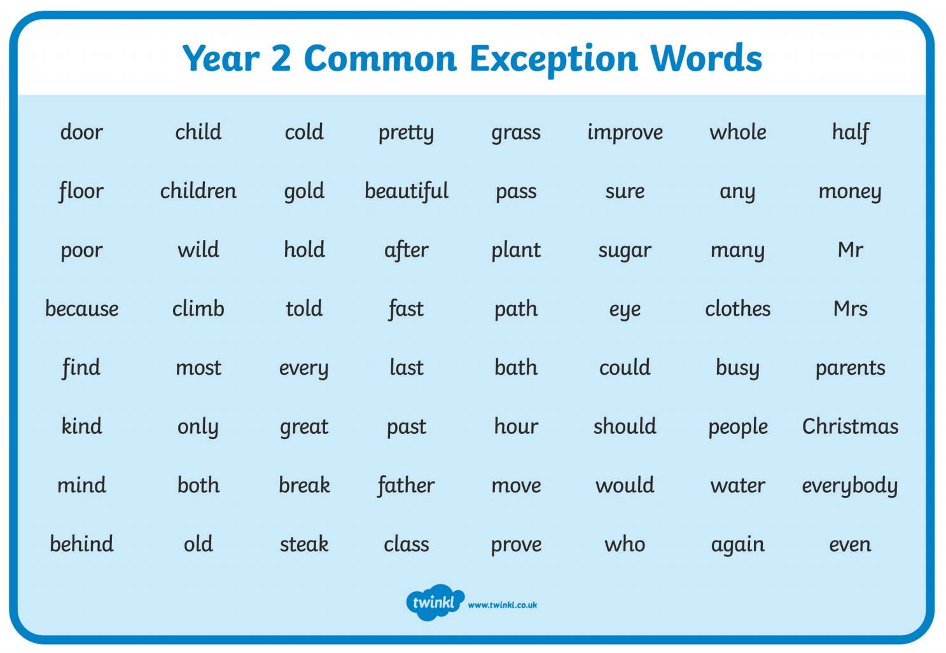

Choose 5 common exception words and practice putting them into interesting sentences.

