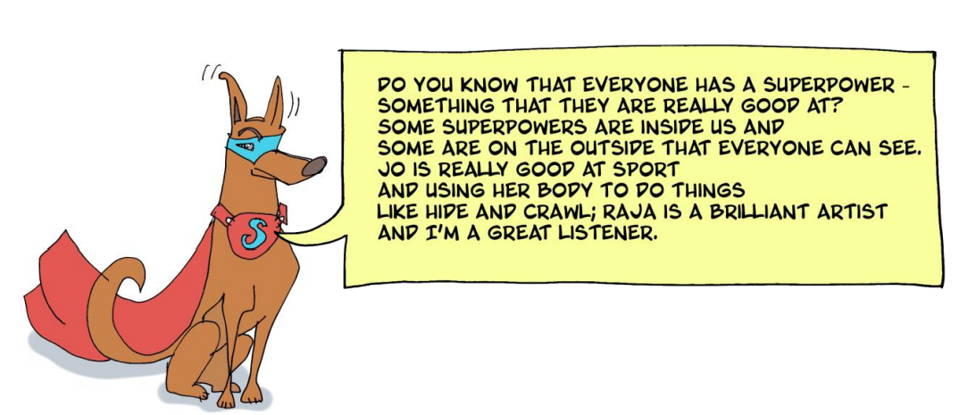
Can you make up a superhero name for yourself?
1. Write your first superhero name here (you could shorten your own name or make up a new superhero name):
____________________
2. Choose an adjective from the list below or think of your own and write it here:
_____________________
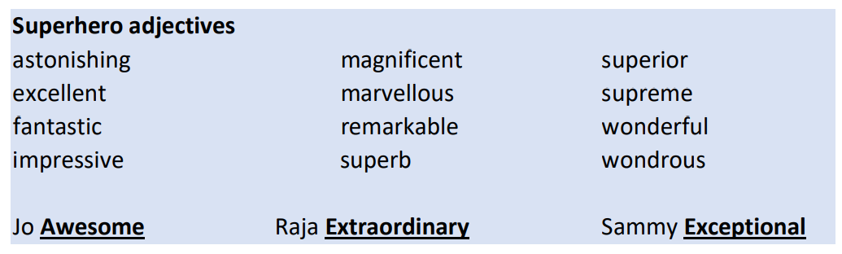
Superhero Name: ______________________________________________________
Now think about all the things you are good at to help you work out your superpowers:
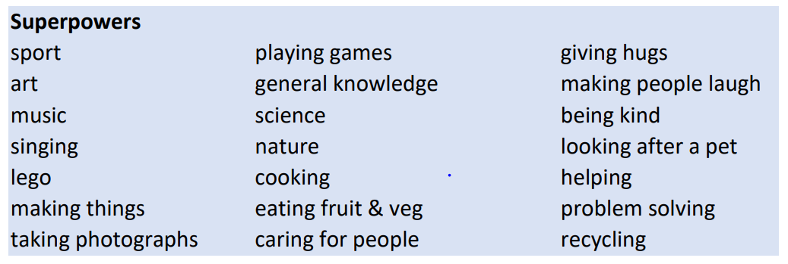

All superheroes have a symbol, like these below:
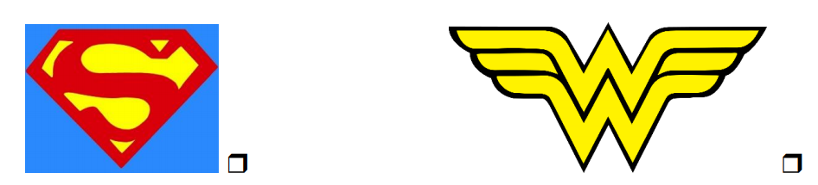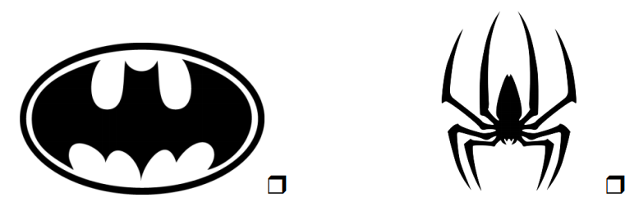
What would your Symbol look like?
Draw a picture of you as a Superhero and create a symbol for yourself.

Explain what your Symbol has on it and why?

