Home Learning Timetable Year 2 - Summer 2 - Week 6 - Week beginning – 6th July
Monday | Tuesday | Wednesday | Thursday | Friday
Literacy  Can you complete the starter test in your new Literacy Collins book from page 4 to page 11. | Literacy  Can you work through some of the pages in your Collins book for 30 minutes. | Literacy  Can you work through some of the pages in your Collins book for 30 minutes. | Literacy  Can you work through some of the pages in your Collins book for 30 minutes. | Literacy  Can you work through some of the pages in your Collins book for 30 minutes.
Maths Focus this week is
The focus lessonthis week are multiplication and division - these lessons are on the Oak Acadamy Website - Year 2 – Maths – Multiplication and division
https://classroom.thenational.academy/subjects-by-year/year-2/subjects/maths
Maths  Can you work through some of the pages in your Collins book for 30 minutes. | Maths  Can you work through some of the pages in your Collins book for 30 minutes. | Maths  Can you work through some of the pages in your Collins book for 30 minutes. | Maths  Can you work through some of the pages in your Collins book for 30 minutes. | Maths  Can you work through some of the pages in your Collins book for 30 minutes.
Topic  This week you will be thinking again about what makes you unique and special. Look at the ebook ‘we are all different’.  Then see worksheet - Topic Monday 1 | Topic  See worksheet - Topic Tuesday  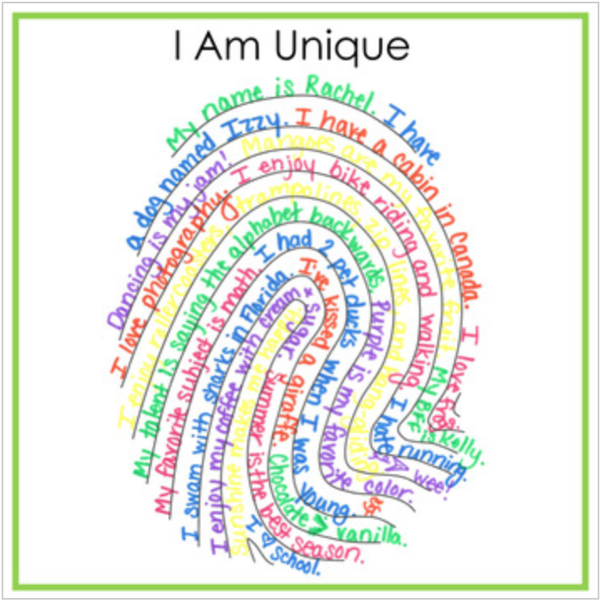 | Topic  See worksheet - Topic Wednesday  Read the scenario with an adult.  If you could write a letter to Bilal, what would you say? | Topic  You have come so far in Year 2 and you have all grown so much as learners. It’s now time to start thinking about and getting ready to fly into Year 3. Change can be hard to deal with, but sometimes, change and trying new things can be wonderful.  See worksheet - Topic Thursday | Topic  We want you to think about your new learning environment in Year 3.  What do you think a good learning environment looks like?  See worksheet - Topic Friday and complete the bird’s nest activity.
Daily Reading
Ask your parent/ carer/ sibling to read to you at bedtime AND spend some time each day reading a book, either to yourself or someone else.

Daily Physical Activity
Complete 10 minutes of daily physical activity. This could be skipping, running, dancing or see joe wicks cards for ideas. OR Join Joe Wicks on YouTube for daily 30 minute home PE sessions at 9AM (see link below)
https://www.thebodycoach.com/blog/pe-with-joe-1254.html

