Michael receives a letter from the principle about his return to school. In this story Michael writes letters to his new teacher to get him out of his first day of school. His imagination runs wild and you may laugh at some of his letters.

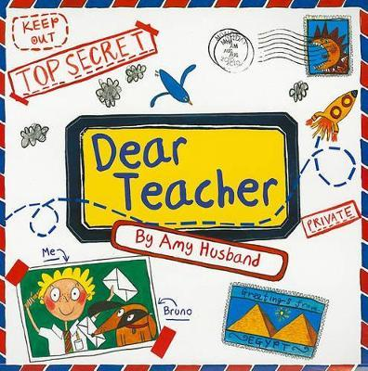https://www.youtube.com/watch?v=cVWvwu31t5g

Did you like the story?

What was your favourite part?

Why do you think Michael was coming up with lots of excuses to get him out of his first day back at school?

Did Michael go to school in the end? Why do you think he went?

Can you think of any funny and crazy ideas like Michael?

