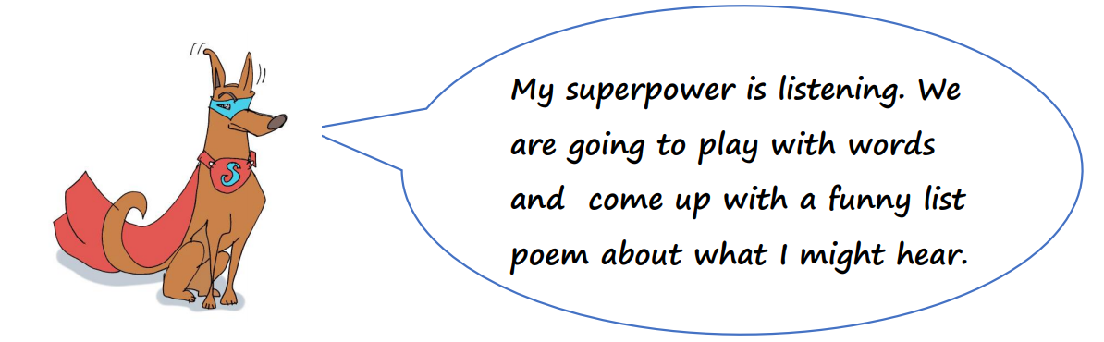
With my special ears,
I heard a giant whispering in his castle in the sky.

With my special ears,
I heard the oak trees talking in a faraway forest.

With my special ears,
I heard the sweet chirping of birds in the distance

With my special ears.
I heard the loud stomping of elephants in the jungle

What is your super power?
Could you create a poem similar, repeating the same sentence starters.
With my special super power……
I can ………
Remember to add in adjectives, verbs and adverbs to make it more exciting if you can.

