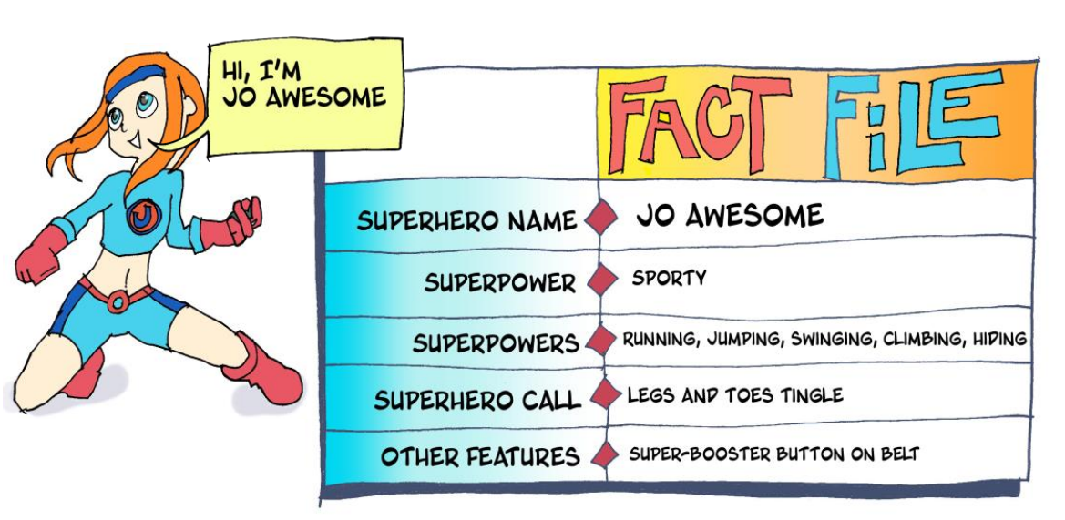
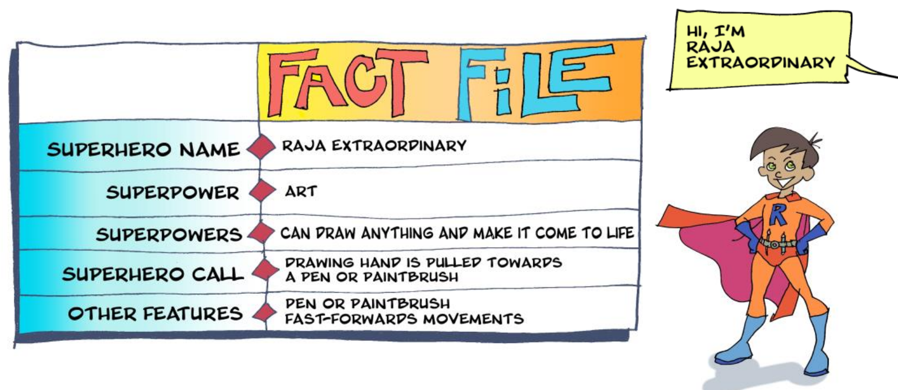
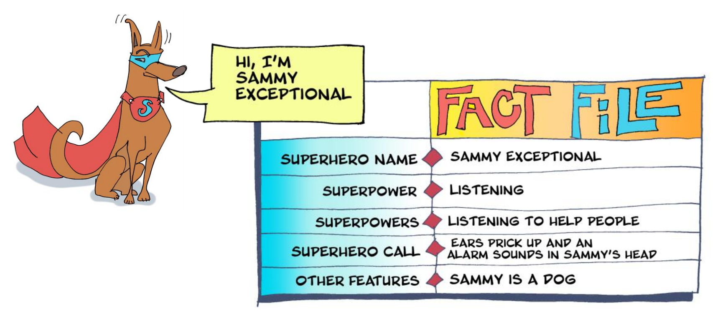

Have a look at the Superheroes Fact files.
Create your own Fact File about you as a Superhero

Fact File
Superhero Name

Super Power

Super Powers

Super hero Call

Other Features

