Today we want you to think about another new word: Discrimination
Do you know what it means?
Discuss it with an adult.

Discrimination is the act of treating people differently or unfairly because things like race, religion or gender.

Discuss this with an adult to help you understand what it means.

Today we have two stories we would like you to read and do some thinking about.
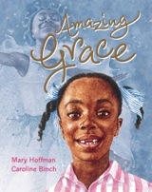

Amazing Grace
https://www.youtube.com/watch?v=_HDwGwWRCTc

Listen to the first story, Amazing Grace.
Discuss and think about what happened in the story and to Grace with an adult.

Now listen to the next story ‘All are welcome’
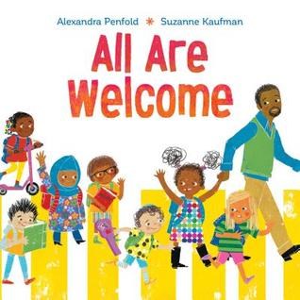

All are welcome
https://www.youtube.com/watch?v=aZXnMS6r_h0

Activity: Comparing both stories.

Which story showed discrimination? And how?

How were children treated in the story ‘All are welcome?’

Did you like the way they were treated? Why?

How was Grace treated by her friends at school?

How do you think this made Grace feel?

What would you say to Grace to make her feel better and help her understand her differences are what make her special?

Can you write her a message from you.

