This week we would like you to think about ways in which you are unique, what makes you different and why it is important we understand and celebrate each other’s differences.
Diversity and discrimination are two important words we would like to introduce to you and get you to think about this week.
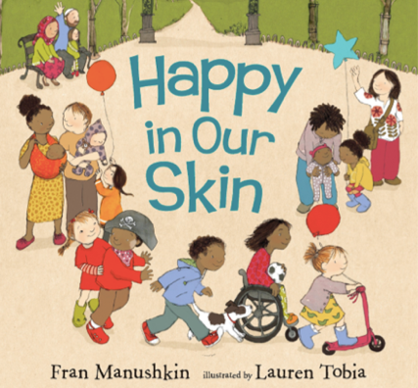
Diversity means there are lots of different kinds of people. It is important we understand that we are all unique. Diversity is a good thing and should always be celebrated.

Look at the front cover of the book, discuss the questions and complete them with an adult.
- How are the people and children different? Make a list of what is different about ALL these people.
- Imagine if we were all the same? What do you think it would be like?
- Discuss and write down a list of some good things about diversity and the fact that everyone is different.
Before listening to the story have a look at this sentence from the book
“yes we all have skin but nobody is you, you are one of a kind”
What do you think it means? Discuss it with an adult.

Listen to the story with an adult. – ‘Happy in our skin’ https://www.youtube.com/watch?v=eabN4NrEMzI

What did you like about the story?

How did the story show diversity?

You could write down any questions that you have about the story or the word diversity for your teacher or adult at home to help you answer

